
NORTH SYDNEY BOYS HIGH SCHOOL
COMPUTING STUDIES DEPARTMENT
SOFTWARE DESIGN AND DEVELOPMENT

HSC ASSESSMENT TASK - PERSONAL SOFTWARE DESIGN PROJECT
(30% of HSC Subject Assessment Mark)

Extract from Syllabus:
Developing a Solution Package
The project(s) in the HSC course is intended to reinforce the content covered in the other topics in the course. Students need to experience working as part of a team, as this is common in the computing field beyond school. In order to be able to develop software successfully, students need to be able communicate well with others and to act in a social and ethical way. The project is one area in which students may be given these opportunities. The project(s) will build students’ understanding of the content dealt with in the other topics in the course and should be undertaken throughout the duration of this course.

Outcomes
A student:
H1.1 explains the interrelationship between hardware and software
H1.2 differentiates between various methods used to construct software solutions
H1.3 describes how the major components of a computer system store and manipulate data
H3.1 identifies and evaluates legal, social and ethical issues in a number of contexts
H3.2 constructs software solutions that address legal, social and ethical issues
H4.1 identifies needs to which software solutions are appropriate
H4.2 applies appropriate development methods to solve software problems
H4.3 applies a modular approach to implement well-structured software solutions and evaluates their effectiveness
H5.1 applies project management techniques to maximise the productivity of the software development
H5.2 creates and justifies the need for the various types of documentation required for a software solution
H5.3 selects and applies appropriate software to facilitate the design and development of software solutions
H6.1 assesses the relationship between the roles of people involved in the software development cycle
H6.2 communicates the processes involved in a software solution to an inexperienced user
H6.3 uses a collaborative approach during the software development cycle
H6.4 develops effective user interfaces, in consultation with appropriate people.

You are required to select a problem/project approved by your teacher which has to be solved using the structured software development approach. You are then required to design and build a working solution using a suitable programming language (e.g. Visual Basic) or one approved by your teacher. Your solution must include full documentation of all stages of the Software Development Cycle and satisfy the Board of Studies requirements. See BOS Support and Specifications Documents:

Refer:
http://www.boardofstudies.nsw.edu.au/syllabus_hsc/pdf_doc/softwaredesign_support.pdf
http://www.boardofstudies.nsw.edu.au/syllabus_hsc/pdf_doc/softwaredesign_specs.pdf

Steps in Project Management
Throughout the project you are expected to complete the standard software development stages, and submit material periodically which relates to each stage:
(1) Defining and Understanding the Problem
(2) Planning and Design
(3) Implementation
(4) Testing and Evaluation
(5) Maintenance

Project Ideas
Stock market simulator Calculator
Student diary Study program system
Appointment system Hotel bookings system
Video store management system Subject choice/report system
Payroll system Cloze test
Stock control Batch banking/ audit system
Text encryption/ analysis Olympic Games ticketing
Library system Connect Four
Mastermind Snakes and Ladders
Hangman Clock Patience
Memory Battleship
Yahtzee Draughts
Search a Word Monopoly
Bingo Ludo
Guess Who Cluedo
Sorry Trouble
Crossword generator Quizzes
Drill and practice games Idiom/Colloquial suggester
Assembler Route Optimizer
Athletics carnival software Resource allocation
Cash register Tenpin bowling scoring
Calculation of sport averages Wedding planner

Project Assessment
Due Dates indicate the final deadline of Friday 1:35pm in the week stated. You are advised to make an appointment with your teacher before the final date indicated for each Check.

If you miss any of the dates indicated below – you need to contact your teacher immediately on return to school and present the necessary medical certificate. If you are involved in any organised school activity on the dates indicated below – you have to arrange an interview with your teacher before the Friday deadline.

Indicate your Name and the Check Number clearly on all written work. [Good idea to include in a header/footer.]

 | Due Date | Weighting
Walkthrough | Term 4 Week 10 2013 | 5%
Check 1: Defining and Understanding the Problem | Term 1 Week 4 2014 | 5%
Check 2: Planning and Design | Term 1 Week 7 2014 | 10%
Check 3: Implementation | Term 2 Week 6 2014 | 10%
Check 4: Testing and Evaluation / Maintenance | Term 3 Week 1 2014 | 10%
Completed Final Project | Term 3 Week 4 2014 | 60%

DETAILS OF STAGES
Walkthrough
You must arrange an appointment with your teacher and discuss the following aspects of your software assessment proposal:
- Definition of the problem to be solved, needs of the ‘client’; boundaries (scope) and an outline of how you intend to solve the problem – submitted to your teacher in writing
- Brief discussion of the approaches and ideas considered and rejected.
Your teacher will be looking for a balanced feasibility study in your consideration of problem and solution offered.
- Printed Gantt Chart showing dates by which you intend to complete each stage shown in the Project Assessment Check Stages
- Discuss the programming language you intend to use and provide a timeline to your teacher that shows how you intend to gain mastery of the language (if you are not already confident in the language)

This interview will last about 10 minutes

Checks 1 thru 4
Documentary evidence is to be presented showing completed work for each stage of the Software Development Cycle. All text documentation is to be word processed, diagrams may be hand-drawn. Include all work completed from prior stages.
Your project logbook will be marked. You are expected to make a minimum of one entry per week. The logbook must be hand-written.

Final Completed Project
All documentation presented in the earlier stages must be submitted as hard copy in a single folder. Intermediate stages of coding are to be included in your printed documentation.
Your printed material must have a table of contents which lists the page numbers for the different aspects. Include a footer and bibliography.
A Checklist for the Software Development Cycle
Note that some tools may be used in more than one stage of the cycle.

Check 1 : Defining and Understanding the Problem
  - A problem statement and initial design specification
  - Screen designs
  - Storyboard showing the initial user interface design
  - Context Diagram
  - Data Flow Diagram (initial version)
  - Gantt Chart of entire project
  - Social / Ethical considerations (e.g. gender bias, copyright, ergonomic, accessibility and plagiarism issues)
  - Logbook of tasks completed, problems encountered, etc.

Check 2 : Planning and Design of Software Solutions
  - Discussion of selection of language to be used (as per Walkthrough)
  - List ALL Functions, Procedures and Modules with a brief description
  - Pseudocode and algorithm (system) flowcharts of ONE module
  - IPO Chart of the main module
  - Structure Chart of ALL modules
  - Define the Files that will be used with their respective Data Structures
  - List the key Variables with their data type and a brief description
  - Data Dictionary (initial version), to include Data Types/Classes
  - Platform/OS considerations and hardware implications of your project
  - Prototype of system to be available for demonstration. E.g. interface and basic functionality
  - Test data that will enable testing of all paths through the algorithm as well as the testing of each boundary condition. If test data for the entire algorithm is not feasible, select one module and create extensive test data for it.
  - Logbook

Check 3 : Implementation of Software Solutions
  - Justify and discuss choice of user interface items selected – e.g. menu, command buttons, check boxes, etc.
  - EBNF and Railroad diagrams
  - Updates (i.e. additional detail) to DFDs and Data Dictionary
  - Selected test data with the corresponding expected output
  - Error checking: Demonstrate use of stubs, flags, debugging output statements
  - Evidence of testing of all pathways, desk check and peer check
  - Evidence of breakpoint, traces and single line stepping
  - Readability of code
  - Discussion of syntax errors, runtime errors, logic errors
  - Documentation: developer, intrinsic, user, technical, installation, online help
  - Compile to executable application or installer-type application
Check 4 : Testing and Evaluation of the Solution
  - Selected test report with test data: pathways, boundary conditions, syntax, logic and expected output
  - Comparison with original specification
  - Efficiency and elegancy of code
  - Describe how alpha and beta testing might be used
  - Refine the user interface

[Maintenance of Software Solution]
  - Describe suitable CASE tools to monitor changes and version control
  - Explain how you would cater for possible changing user requirements
  - How would you handle updates to the code? E.g. changes to the environment
  - Logbook to record any changes in code, design, etc.

Final Project (written component) :
  - Fully updated Storyboard
  - User Manual
  - Technical / Installation Manual
  - Screen shots
  - Printout of a sample of source code
  - Project report outlining what you have learnt from your work on this project, future directions and modifications of your software
  - Bibliography that details sources of information/ideas, assistance with coding, etc.
  - Peer Check reports
  - Completed Logbook

Breakup of Marking Criteria for Final Project

Printed documentation - user and technical/installation manuals, screen shots |  | 20%
Project report |  | 5%
A working tested program with all associated documentation to be submitted on a CD or USB thumb drive. |  | 30%
You will be required to present all aspects of your final project to the class. |  | 5%
Total |  | 60%

Example of a Structure Chart
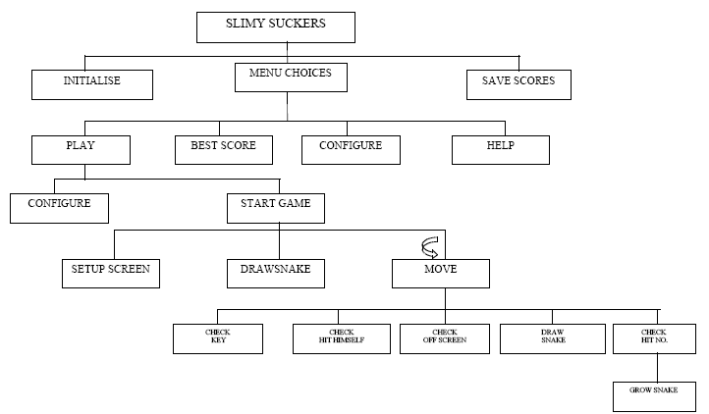

Example of a Gantt Chart

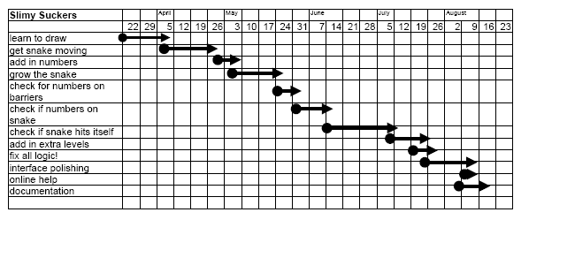

Example of Data Dictionary
ELEMENT | LENGTH | TYPE | DESCRIPTION
again$ | 1 | Alpha | Asks the player whether he'd like to play again
back |  | numeric | variable name of the square dimensioned (back square)
backrou$ | 1 | Alpha | colour of the background
backrou |  | numeric | colour of the background
colourl | 10 | Alpha | colour of the border
colour2 | 10 | Alpha | colour of the snake
cover |  | numeric | used so the next number doesn't appear where the snake is located
falg |  | numeric | a flag set to know whether to increment the variable 'numb'
flag |  | numeric | program will drop out of the 'move' loop to perform a different task
helpch |  | numeric | choice from help menu
increase$ | 1 | Alpha | whether the speed increases through the game
index |  | numeric | An index used in "Configuration'⁹ to be index to direction$(5)
keypress |  | numeric | the ACSII value of keypress 1$
keypress 1$ | 1 | Alpha | the key entered by the player to make his snake move
lastkeypress |  | numeric | before a new keypress is entered, the old one becomes lastkeypress
Lives |  | numeric | How many lives the player has left
mmenu |  | numeric | choice from main menu
Nam$ | 15 | Alpha | name of player
Nexts |  | numeric | The level number that the player is up to
Numb |  | numeric | The counter of which is the next number the snake must 'swallow'
pause |  | numeric | flag set to say the game was just paused
rectg |  | numeric | variable name of the square dimensioned (front square)
rect |  | numeric | variable name of the square dimensioned (front square)
Rndmx |  | numeric | a random horizontal value where a number will be placed to be collected
Rndmy |  | numeric | a random vertical value where a number will be placed to be collected
Shape |  | numeric | The choice of shape by the user, It determines the shape of the snake
score! |  | numeric | the players score throughout the game
snake$ | 20 | Alpha | name of player's snake
speed |  | numeric | speed at which the snake moves
pole |  | numeric | a flag set to tell if the validation of the keys was OK
upto |  | numeric | A count to see what part of the subroutine it is up to
vpos |  | numeric | the vertical position of an error message
hpos |  | numeric | the horizontal position of an error message
x |  | numeric | the current position of the snake (horizontal)
Y |  | numeric | the current position of the snake (vertical)
ARRAYS
bestname$ | 10 | array | array where top ten players are sorted and then written to disk
bestscores | 10 | array | array where top ten scores are sorted and then written to disk
direction | 5 | array | these keys are converted to ASCII values
direction$ | 5 | array | player chooses the keys he wishes to play with
done | 10 | array | an array pointing out if a message has already been done
startx | 640, 200 | array | The starting "x" position of the barrier and the number barrier
Starty | 480, 200 | array | The starting "Y" position of the barrier and the number barrier
endx | 640, 200 | array | The end "x" position of the barrier and the number barrier
endy | 480, 200 | array | The end "y" position of the barrier and the number barrier
snake$ | 640, 480 | array | Horizontal and Vertical Position of the snake
Lengt | 9 | array | As each number is picked up, the snake grows to this certain length
Randm | 10 | array | an array containing 10 different random messages

